11.2 Position of equilibrium
Name: ____________________ Class: ____________________ Due date: 11.11
1. The formation of sulfur trioxide from sulfur dioxide is a reversible reaction.
$$2SO_{2}(g)+O_{2}(g)⇌2SO_{3}(g)$$
The forward reaction is exothermic.
$SO_{3}$Which changes would increase the equilibrium yield of ? （ ）
1 increasing the pressure
2 lowering the temperature
3 decreasing the concentration of oxygen
A 1,2 and 3 B 1 and 2 only C 1 only D 2 and 3 only

2. The formation of sulfur trioxide is a reversible reaction.
The equation is shown.
$$2SO_{2}(g)+O_{2}(g)⇌2SO_{3}(g)$$
The forward reaction is exothermic.
Which conditions produce the highest equilibrium yield of sulfur trioxide? （ ）
 | pressure | temperature
A | high | high
B | high | low
C | low | high
D | low | low

3 .Sulfur dioxide reacts with oxygen at 2 atmospheres pressure. The forward reaction is exothermic.
The equation for the reaction is shown.
$$2SO_{2}(g)+O_{2}(g)⇌2SO_{3}(g)$$
The reaction reaches equilibrium. The pressure is then doubled.
How and why does the amount of sulfur trioxide formed change? （ ）
 | amount of sulfur trioxide | reason
A | decreases | the forward reaction is exothermic
B | decreases | there are fewer molecules on the right
C | increases | the forward reaction is exothermic
D | increases | there are fewer molecules on the right

4 . Methanol is prepared by the reversible reaction shown.
$$CO(g)+2H_{2}(g)⇌{CH}_{3}OH(g)$$
The forward reaction is exothermic.
Which conditions produce the highest equilibrium yield of methanol? （ ）
 | temperature | pressure
A | high | high
B | high | low
C | low | high
D | low | low

5. The reversible reaction between methane and steam is shown.
$${CH}_{4}(g)+H_{2}O(g)⇌CO(g)+3H_{2}(g)$$
The forward reaction is endothermic.
Which changes in pressure and temperature move the equilibrium to the right?（ ）
 | pressure | temperature
A | decrease | decrease
B | decrease | increase
C | increase | decrease
D | increase | increase

6. Chloride P is converted to chloride Q by reaction with chlorine in a closed system.
The reversible reaction reaches an equilibrium.
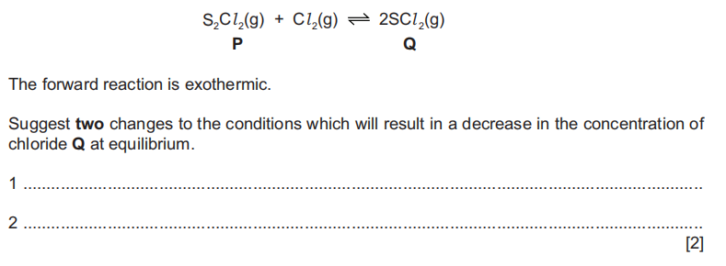
7. Nitryl chloride, NO₂Cl, reacts with nitric oxide, NO.
The forward reaction is exothermic
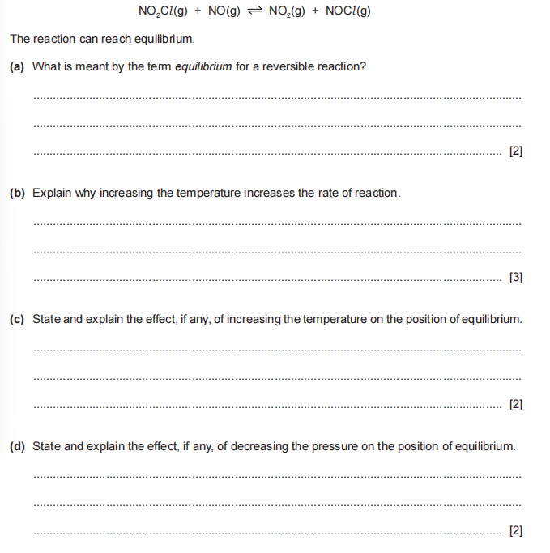
The reaction can reach equilibrum.
(a)What is meant by the term equilibrium for a reversible reaction?
..................................................................................................................................
..................................................................................................................................[2]
(b)Explain why increasing the temperature increases the rate of reaction
..................................................................................................................................
..................................................................................................................................
..................................................................................................................................[3]
(c)State and explain the effect, if any, of increasing the temperature on the position of equilibrium.
..................................................................................................................................
..................................................................................................................................[2]
(d) State and explain the effect, if any, of decreasing the pressure on the position of equilibrium.
..................................................................................................................................
..................................................................................................................................[2]

